Ch. Bhargav Ram
192425334
INTERNET PROGRAMING-CSA4308

LAB PROGRAMS
1. A local library needs a website to streamline operations and enhance user experience. The site will include a catalogue for searching and viewing books, user accounts for borrowing and managing books, and an admin dashboard for managing inventory and user data. Essential features include a search function, book details page, user login system, and contact form, The system helps both students and library managers to keep constant track of all the books available in the library. It allows both the admin and the student to search for the desired book. It becomes necessary for colleges to keep a continuous check on the books issued and returned and even calculate fines.
1ST PROGRAM
<!DOCTYPE html>
<html lang="en">
<head>
<meta charset="UTF-8">
<meta name="viewport" content="width=device-width, initial-scale=1.0">
<title>Library Management System</title>

<style>
*{
margin:0;
padding:0;
box-sizing:border-box;
font-family:Arial, sans-serif;
}

body{
background:#f2f2f2;
}

header{
background:#2c3e50;
color:white;
padding:20px;
text-align:center;
}

nav{
background:#34495e;
padding:15px;
text-align:center;
}

nav a{
color:white;
text-decoration:none;
margin:20px;
font-size:18px;
}

nav a:hover{
color:yellow;
}

.hero{
padding:50px;
text-align:center;
background:white;
}

.hero h1{
color:#2c3e50;
}

.hero p{
margin-top:15px;
font-size:18px;
}

.container{
display:flex;
justify-content:space-around;
margin:40px;
}

.card{
background:white;
padding:20px;
width:250px;
border-radius:10px;
box-shadow:0 0 10px gray;
text-align:center;
}

.card h3{
margin-bottom:15px;
}

.card button{
background:#2c3e50;
color:white;
padding:10px 20px;
border:none;
cursor:pointer;
margin-top:15px;
}

.card button:hover{
background:#27ae60;
}

footer{
background:#2c3e50;
color:white;
text-align:center;
padding:20px;
margin-top:40px;
}
</style>

</head>
<body>

<header>
<h1>Library Management System</h1>
<p>Online Book Management Portal</p>
</header>

<nav>
<a href="#">Home</a>
<a href="#">Books</a>
<a href="#">Login</a>
<a href="#">Register</a>
<a href="#">Contact</a>
</nav>

<section class="hero">
<h1>Welcome to Library</h1>

<p>
Search books, borrow books, check fines and download study materials.
</p>

</section>

<div class="container">

<div class="card">
<h3>Search Books</h3>
<p>Find books by title, author or category.</p>
<button>Search</button>
</div>

<div class="card">
<h3>Student Login</h3>
<p>View borrowed books and download materials.</p>
<button>Login</button>
</div>

<div class="card">
<h3>Admin Login</h3>
<p>Manage books, students and fines.</p>
<button>Admin</button>
</div>

</div>

<footer>

<p>© 2026 Library Management System</p>

</footer>

</body>
</html>
OUT PUT:

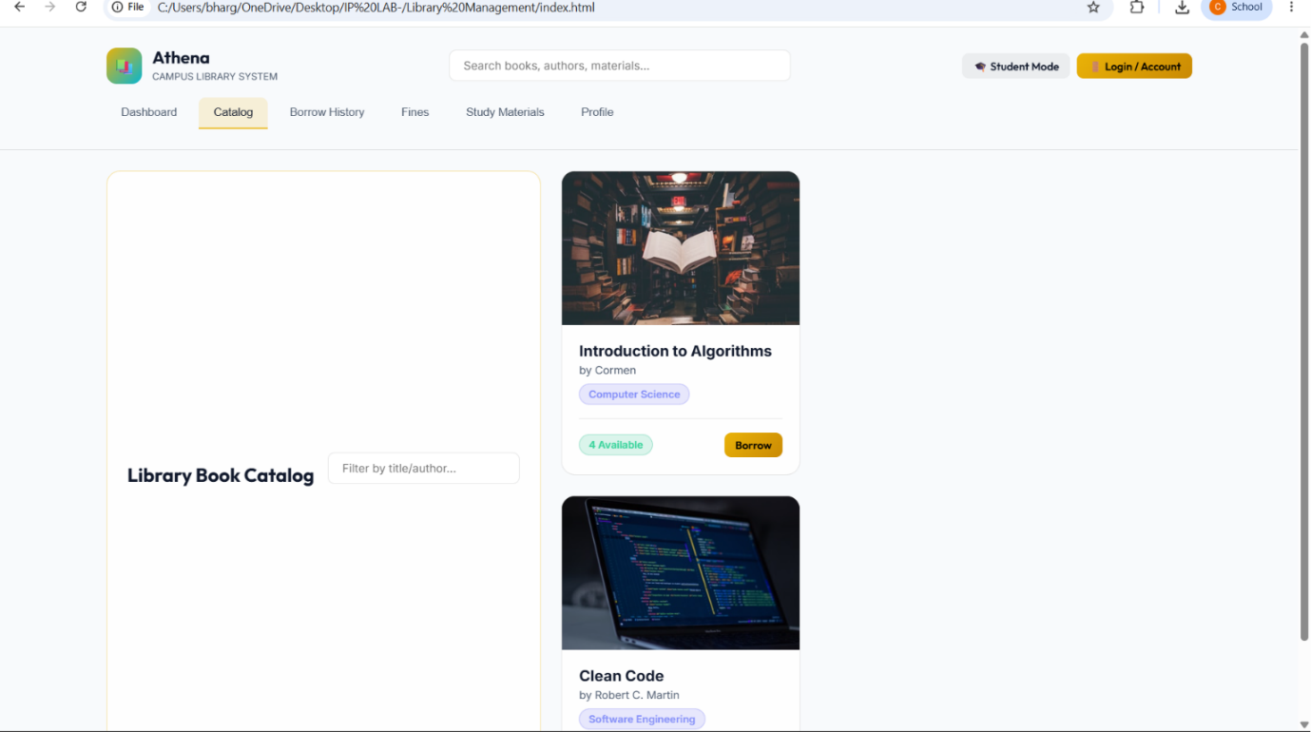

2)The online hotel room booking website allows users to search for hotels based on destination, dates, and number of guests, offering detailed listings with room options, prices, amenities, and reviews. Users can create accounts, log in, and manage their bookings through a user-friendly dashboard. The booking process includes checking room availability, filling out a booking form, and completing secure payments via an integrated payment gateway. Post-booking, users receive confirmation emails and can leave reviews and ratings. Admins manage hotel listings, room availability, and user accounts through a dedicated admin panel. The website is fully
PROGRAM
<!DOCTYPE html>
<html lang="en">
<head>
<meta charset="UTF-8">
<meta name="viewport" content="width=device-width, initial-scale=1.0">
<title>Online Hotel Booking System</title>

<style>
*{
margin:0;
padding:0;
box-sizing:border-box;
font-family:Arial, Helvetica, sans-serif;
}

body{
background:#f4f4f4;
}

header{
background:#0d47a1;
color:white;
padding:20px;
text-align:center;
}

nav{
background:#1565c0;
padding:15px;
text-align:center;
}

nav a{
color:white;
text-decoration:none;
margin:15px;
font-size:18px;
}

nav a:hover{
color:yellow;
}

.hero{
background:url("https://images.unsplash.com/photo-1566073771259-6a8506099945?w=1600") center/cover;
height:450px;
display:flex;
justify-content:center;
align-items:center;
color:white;
text-align:center;
}

.hero h1{
font-size:45px;
}

.search-box{
background:white;
width:90%;
max-width:1000px;
margin:-50px auto 30px;
padding:20px;
border-radius:10px;
box-shadow:0 0 10px gray;
}

.search-box form{
display:grid;
grid-template-columns:repeat(auto-fit,minmax(180px,1fr));
gap:15px;
}

input,select{
padding:10px;
font-size:16px;
}

button{
background:#1565c0;
color:white;
border:none;
padding:12px;
cursor:pointer;
font-size:16px;
}

button:hover{
background:#0d47a1;
}

.section{
padding:40px;
}

.cards{
display:flex;
flex-wrap:wrap;
justify-content:center;
gap:20px;
}

.card{
background:white;
width:280px;
border-radius:10px;
box-shadow:0 0 10px #ccc;
overflow:hidden;
}

.card img{
width:100%;
height:180px;
}

.card h3{
padding:10px;
}

.card p{
padding:0 10px 10px;
}

footer{
background:#0d47a1;
color:white;
text-align:center;
padding:20px;
margin-top:30px;
}
</style>

</head>
<body>

<header>
<h1>Online Hotel Room Booking System</h1>
<p>Book Luxury Rooms at Affordable Prices</p>
</header>

<nav>
<a href="#">Home</a>
<a href="#">Rooms</a>
<a href="#">Booking</a>
<a href="#">About Us</a>
<a href="#">Contact</a>
<a href="#">Login</a>
<a href="#">Register</a>
</nav>

<div class="hero">
<div>
<h1>Find Your Perfect Stay</h1>
<p>Easy Online Hotel Booking</p>
</div>
</div>

<div class="search-box">

<form>

<input type="text" placeholder="Destination">

<input type="date">

<input type="date">

<select>
<option>1 Guest</option>
<option>2 Guests</option>
<option>3 Guests</option>
<option>4 Guests</option>
</select>

<button>Search Rooms</button>

</form>

</div>

<section class="section">

<h2 align="center">Room Types</h2>

<br>

<div class="cards">

<div class="card">
<img src="https://via.placeholder.com/300x180" alt="Standard Room">
<h3>Standard Room</h3>
<p>Free Wi-Fi, TV, AC, Queen Bed</p>
<p><b>$80 / Night</b></p>
<button>Book Now</button>
</div>

<div class="card">
<img src="https://via.placeholder.com/300x180" alt="Deluxe Room">
<h3>Deluxe Room</h3>
<p>King Bed, Breakfast Included</p>
<p><b>$120 / Night</b></p>
<button>Book Now</button>
</div>

<div class="card">
<img src="https://via.placeholder.com/300x180" alt="Suite">
<h3>Executive Suite</h3>
<p>Luxury Suite with Balcony</p>
<p><b>$180 / Night</b></p>
<button>Book Now</button>
</div>

<div class="card">
<img src="https://via.placeholder.com/300x180" alt="Family Room">
<h3>Family Room</h3>
<p>Large Room for Families</p>
<p><b>$220 / Night</b></p>
<button>Book Now</button>
</div>

</div>

</section>

<section class="section">

<h2>About Us</h2>

<p>
Our Online Hotel Booking System provides a simple and secure way to book hotel rooms.
Users can search rooms, check availability, manage bookings, and enjoy a comfortable stay.
</p>

</section>

<section class="section">

<h2>Customer Service Q & A</h2>

<ul>
<li>✔ Free cancellation up to 3 days before arrival.</li>
<li>✔ Secure online payment.</li>
<li>✔ 24×7 customer support.</li>
<li>✔ Instant booking confirmation.</li>
</ul>

</section>

<section class="section">

<h2>Contact Us</h2>

<p>Email: support@hotelbooking.com</p>
<p>Phone: +1 9876543210</p>
<p>Address: 123 Main Street, City</p>

</section>

<footer>

<p>© 2026 Online Hotel Booking System | Privacy Policy</p>

</footer>

</body>
</html>
OUTPUT :
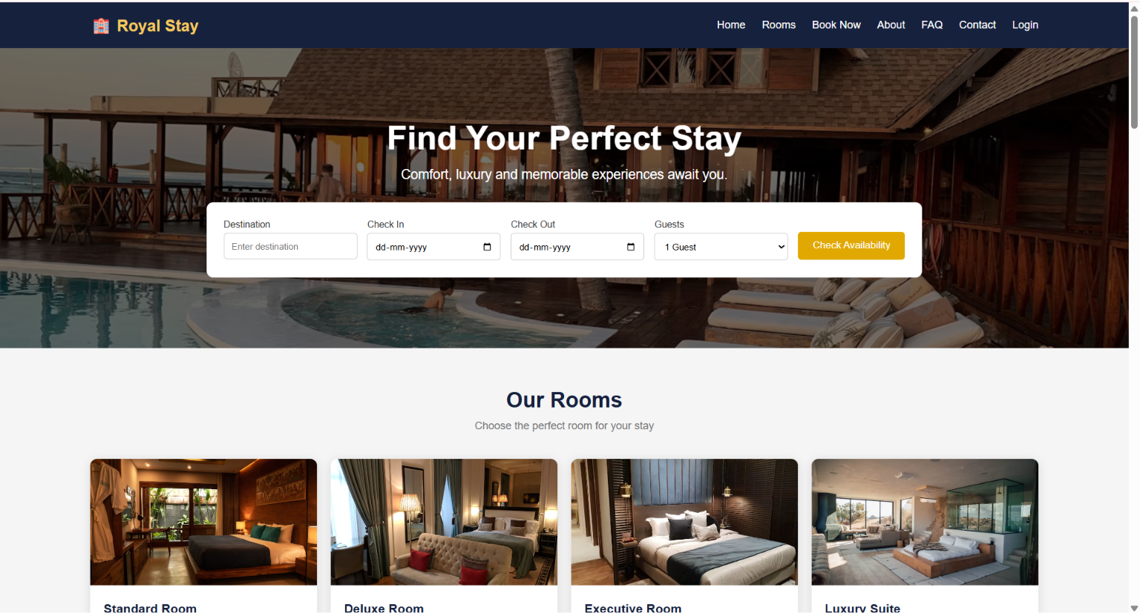

3)The online bus ticket booking system enables users to search for buses by route, date, and time, and view available seats. Users can create an account, log in, and manage their bookings through a personal dashboard. The booking process includes selecting seats, filling out passenger details, and making secure payments via an integrated payment gateway. Admins can manage bus schedules, seat availability, and user accounts through an admin panel. Users receive booking confirmation emails and can view their booking history. The website is mobile responsive, ensuring easy access on all devices.
PROGRAM
<!DOCTYPE html>
<html lang="en">
<head>
<meta charset="UTF-8">
<meta name="viewport" content="width=device-width, initial-scale=1.0">
<title>Online Bus Ticket Booking System</title>

<style>
*{
margin:0;
padding:0;
box-sizing:border-box;
font-family:Arial, Helvetica, sans-serif;
}

body{
background:#f4f4f4;
}

header{
background:#0066cc;
color:white;
text-align:center;
padding:20px;
}

nav{
background:#004d99;
padding:15px;
text-align:center;
}

nav a{
color:white;
text-decoration:none;
margin:15px;
font-size:18px;
}

nav a:hover{
color:yellow;
}

.hero{
background:#0099ff;
color:white;
text-align:center;
padding:60px 20px;
}

.search{
background:white;
width:90%;
max-width:1000px;
margin:20px auto;
padding:20px;
border-radius:8px;
box-shadow:0 0 10px gray;
}

.search form{
display:grid;
grid-template-columns:repeat(auto-fit,minmax(180px,1fr));
gap:15px;
}

input,select{
padding:10px;
font-size:16px;
}

button{
background:#0066cc;
color:white;
border:none;
padding:12px;
cursor:pointer;
}

button:hover{
background:#004d99;
}

.section{
padding:40px;
}

.cards{
display:flex;
flex-wrap:wrap;
justify-content:center;
gap:20px;
}

.card{
background:white;
width:280px;
padding:20px;
border-radius:10px;
box-shadow:0 0 8px gray;
}

.card h3{
color:#0066cc;
margin-bottom:10px;
}

footer{
background:#004d99;
color:white;
text-align:center;
padding:20px;
margin-top:30px;
}
</style>

</head>
<body>

<header>
<h1>Online Bus Ticket Booking System</h1>
<p>Book Your Journey Anytime, Anywhere</p>
</header>

<nav>
<a href="#">Home</a>
<a href="#">Search Bus</a>
<a href="#">Book Ticket</a>
<a href="#">Booking History</a>
<a href="#">Login</a>
<a href="#">Register</a>
<a href="#">Contact</a>
</nav>

<section class="hero">
<h1>Find & Book Your Bus Tickets</h1>
<p>Easy • Secure • Fast Booking</p>
</section>

<div class="search">

<h2>Search Bus</h2>
<br>

<form>

<input type="text" placeholder="From">

<input type="text" placeholder="To">

<input type="date">

<select>
<option>Select Time</option>
<option>Morning</option>
<option>Afternoon</option>
<option>Evening</option>
<option>Night</option>
</select>

<button type="submit">Search Bus</button>

</form>

</div>

<section class="section">

<h2 align="center">Available Bus Categories</h2>
<br>

<div class="cards">

<div class="card">
<h3>Volvo Bus</h3>
<p>Luxury AC Bus with Pushback Seats</p>
<p>Available Seats : 30</p>
<button>Book Now</button>
</div>

<div class="card">
<h3>Sleeper Coach</h3>
<p>Comfortable Sleeper Berths</p>
<p>Available Seats : 18</p>
<button>Book Now</button>
</div>

<div class="card">
<h3>AC Coach</h3>
<p>Air Conditioned Coach</p>
<p>Available Seats : 25</p>
<button>Book Now</button>
</div>

<div class="card">
<h3>Non-AC Coach</h3>
<p>Economy Travel Option</p>
<p>Available Seats : 35</p>
<button>Book Now</button>
</div>

</div>

</section>

<section class="section">

<h2>User Services</h2>

<ul>
<li>✔ User Registration</li>
<li>✔ User Login</li>
<li>✔ Search Buses</li>
<li>✔ Book Tickets</li>
<li>✔ Cancel Tickets</li>
<li>✔ View Booking History</li>
<li>✔ View Seat Availability</li>
<li>✔ Secure Online Payment</li>
</ul>

</section>

<section class="section">

<h2>Administrator Services</h2>

<ul>
<li>✔ Admin Login</li>
<li>✔ Manage Bus Categories</li>
<li>✔ Add / Update Bus Information</li>
<li>✔ Manage Users</li>
<li>✔ Manage Seat Availability</li>
<li>✔ Generate Reports</li>
<li>✔ Manage News</li>
<li>✔ Manage Comments</li>
</ul>

</section>

<section class="section">

<h2>Customer Comments</h2>

<textarea rows="5" cols="70"
placeholder="Write your feedback here..."></textarea>

<br><br>

<button>Post Comment</button>

</section>

<section class="section">

<h2>Contact Us</h2>

<p>Email : support@busticket.com</p>

<p>Phone : +1 9876543210</p>

<p>Address : Bus Booking Center, Main City</p>

</section>

<footer>

<p>© 2026 Online Bus Ticket Booking System | All Rights Reserved</p>

</footer>

</body>
</html>
OUT PUT:
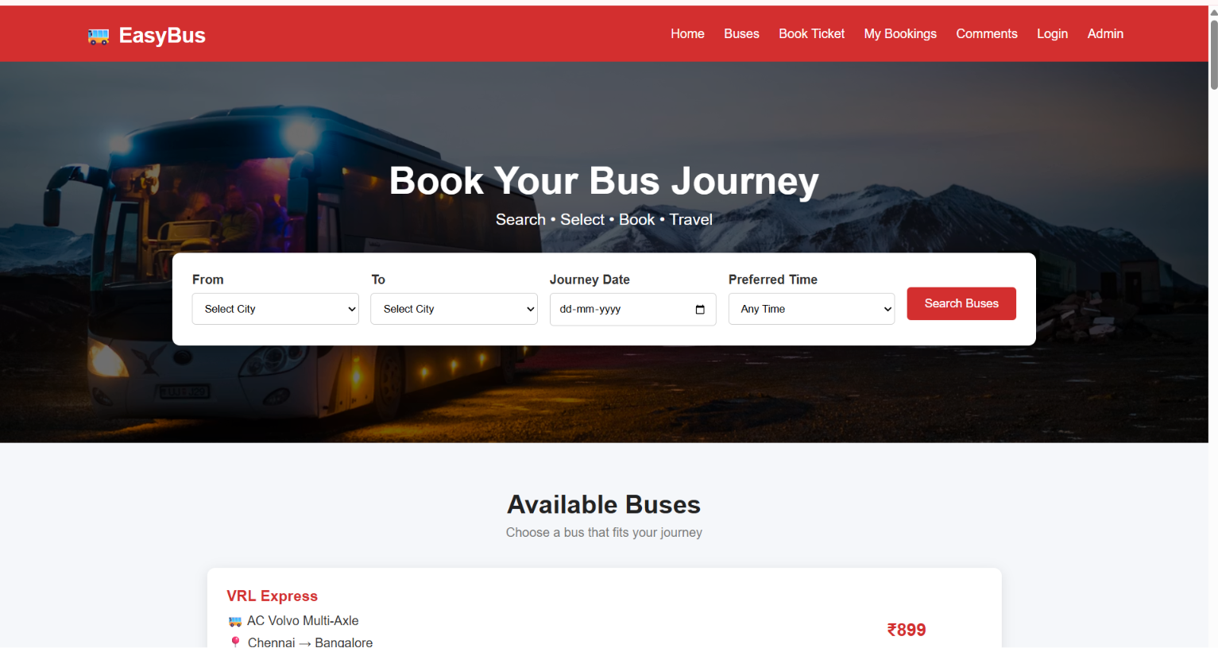

4) The online train reservation system allows users to search for trains by route, date, and time, and view available seats and classes. Users can register, log in, and manage their reservations through a personal dashboard. The booking process involves selecting seats, entering passenger details, and making secure payments via an integrated payment gateway. Admins can manage train schedules, seat availability, and user accounts through a comprehensive admin panel. Users receive booking confirmation emails and can view their booking history and print tickets from their dashboard. The website features real-time seat availability updates and is fully responsive for seamless use on all devices.
PROGRAM
<!DOCTYPE html>
<html lang="en">
<head>
<meta charset="UTF-8">
<meta name="viewport" content="width=device-width, initial-scale=1.0">
<title>Online Train Reservation System</title>

<style>
*{
margin:0;
padding:0;
box-sizing:border-box;
font-family:Arial, sans-serif;
}

body{
background:#f4f4f4;
}

header{
background:#00695c;
color:white;
text-align:center;
padding:20px;
}

nav{
background:#004d40;
padding:15px;
text-align:center;
}

nav a{
color:white;
text-decoration:none;
margin:15px;
font-size:18px;
}

nav a:hover{
color:yellow;
}

.hero{
background:#26a69a;
color:white;
text-align:center;
padding:60px 20px;
}

.container{
width:90%;
max-width:1100px;
margin:auto;
}

.search-box{
background:white;
padding:20px;
margin-top:20px;
border-radius:8px;
box-shadow:0 0 10px gray;
}

form{
display:grid;
grid-template-columns:repeat(auto-fit,minmax(180px,1fr));
gap:15px;
}

input,select{
padding:10px;
font-size:16px;
}

button{
background:#00695c;
color:white;
border:none;
padding:12px;
cursor:pointer;
}

button:hover{
background:#004d40;
}

.section{
margin-top:30px;
background:white;
padding:20px;
border-radius:8px;
box-shadow:0 0 10px #ccc;
}

table{
width:100%;
border-collapse:collapse;
margin-top:15px;
}

table,th,td{
border:1px solid #999;
}

th,td{
padding:10px;
text-align:center;
}

th{
background:#00695c;
color:white;
}

footer{
background:#004d40;
color:white;
text-align:center;
padding:20px;
margin-top:30px;
}
</style>

</head>
<body>

<header>
<h1>Online Train Reservation System</h1>
<p>Book Your Train Tickets Easily</p>
</header>

<nav>
<a href="#">Home</a>
<a href="#">Search Trains</a>
<a href="#">PNR Status</a>
<a href="#">Booking History</a>
<a href="#">Login</a>
<a href="#">Register</a>
<a href="#">Contact</a>
</nav>

<section class="hero">
<h1>Search & Reserve Train Tickets</h1>
<p>Fast • Secure • Easy Booking</p>
</section>

<div class="container">

<div class="search-box">

<h2>Train Search</h2>
<br>

<form>

<input type="text" placeholder="From Station">

<input type="text" placeholder="To Station">

<input type="date">

<select>
<option>Select Class</option>
<option>Sleeper (SL)</option>
<option>3A</option>
<option>2A</option>
<option>1A</option>
<option>Chair Car (CC)</option>
</select>

<button type="submit">Search Trains</button>

</form>

</div>

<div class="section">

<h2>Available Trains</h2>

<table>

<tr>
<th>Train No</th>
<th>Train Name</th>
<th>Departure</th>
<th>Arrival</th>
<th>Seats</th>
<th>Action</th>
</tr>

<tr>
<td>12627</td>
<td>Karnataka Express</td>
<td>08:00</td>
<td>18:30</td>
<td>Available</td>
<td><button>Book</button></td>
</tr>

<tr>
<td>12723</td>
<td>Telangana Express</td>
<td>09:30</td>
<td>20:15</td>
<td>Available</td>
<td><button>Book</button></td>
</tr>

<tr>
<td>12650</td>
<td>Sampark Kranti</td>
<td>11:00</td>
<td>22:00</td>
<td>RAC</td>
<td><button>Book</button></td>
</tr>

</table>

</div>

<div class="section">

<h2>Check PNR Status</h2>

<br>

<input type="text" placeholder="Enter PNR Number">

<button>Check Status</button>

</div>

<div class="section">

<h2>Passenger Services</h2>

<ul>
<li>User Registration & Login</li>
<li>Train Search</li>
<li>Seat Availability</li>
<li>Book Tickets</li>
<li>Online / Offline Payment</li>
<li>Booking History</li>
<li>Print Ticket</li>
<li>Cancel Ticket</li>
<li>Refund Status</li>
<li>PNR Status Check</li>
</ul>

</div>

<div class="section">

<h2>Administrator Services</h2>

<ul>
<li>Manage Train Details</li>
<li>Manage Routes</li>
<li>Manage Seat Availability</li>
<li>Manage Users</li>
<li>Update Fare Details</li>
<li>Manage Refund Rules</li>
<li>Generate Reports</li>
<li>View Payment Details</li>
</ul>

</div>

<div class="section">

<h2>Contact Us</h2>

<p>Email: support@trainreservation.com</p>
<p>Phone: +1 9876543210</p>
<p>Address: Railway Reservation Office</p>

</div>

</div>

<footer>

<p>© 2026 Online Train Reservation System | All Rights Reserved</p>

</footer>

</body>
</html>
OUTPUT:
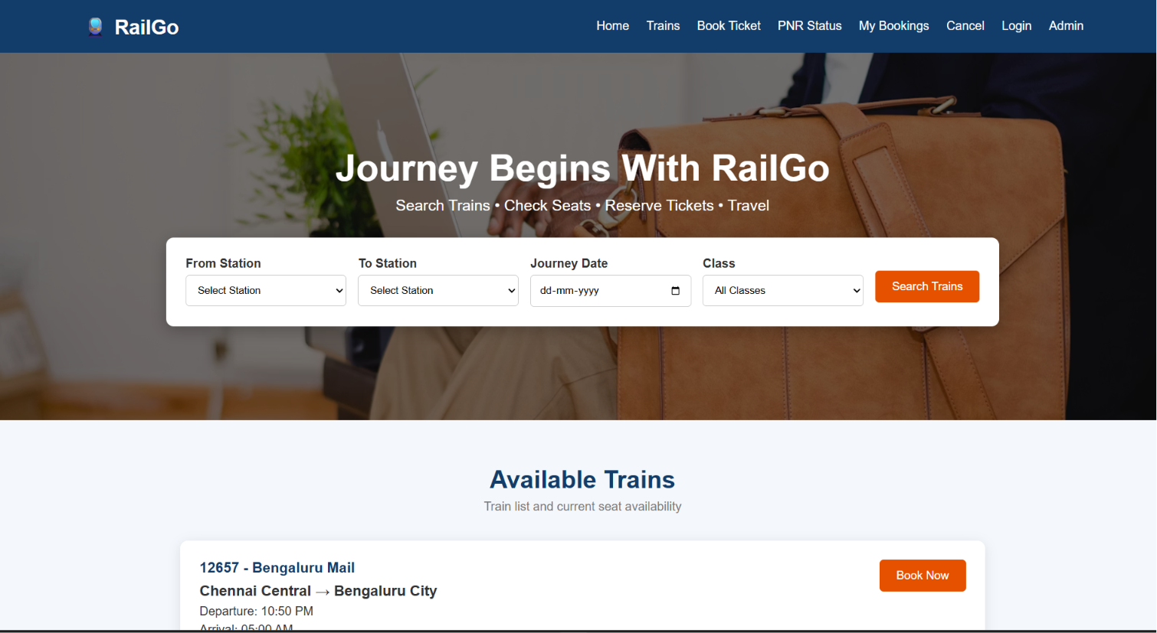

5) The online flight reservation system enables users to search for flights by destination, date, and class, displaying available options with real-time seat availability. Users can register, log in, and manage their reservations via a personal dashboard. The booking process includes selecting flights, choosing seats, entering passenger details, and making secure payments through an integrated payment gateway. Admins can manage flight schedules, seat inventory, and user accounts using an advanced admin panel. Users receive booking confirmation emails with e-tickets and can view their booking history
PROGRAM
<!DOCTYPE html>
<html lang="en">
<head>
<meta charset="UTF-8">
<meta name="viewport" content="width=device-width, initial-scale=1.0">
<title>Online Flight Reservation System</title>

<style>
*{
margin:0;
padding:0;
box-sizing:border-box;
font-family:Arial, sans-serif;
}

body{
background:#f5f5f5;
}

header{
background:#0b5394;
color:white;
text-align:center;
padding:20px;
}

nav{
background:#073763;
padding:15px;
text-align:center;
}

nav a{
color:white;
text-decoration:none;
margin:15px;
font-size:18px;
}

nav a:hover{
color:yellow;
}

.hero{
background:#4a90e2;
color:white;
text-align:center;
padding:60px;
}

.container{
width:90%;
max-width:1100px;
margin:auto;
}

.search{
background:white;
margin-top:20px;
padding:20px;
border-radius:10px;
box-shadow:0 0 10px #bbb;
}

form{
display:grid;
grid-template-columns:repeat(auto-fit,minmax(180px,1fr));
gap:15px;
}

input,select{
padding:10px;
font-size:16px;
}

button{
background:#0b5394;
color:white;
border:none;
padding:12px;
cursor:pointer;
}

button:hover{
background:#073763;
}

.section{
background:white;
margin-top:25px;
padding:20px;
border-radius:10px;
box-shadow:0 0 10px #ccc;
}

table{
width:100%;
border-collapse:collapse;
margin-top:15px;
}

table,th,td{
border:1px solid gray;
}

th{
background:#0b5394;
color:white;
}

th,td{
padding:10px;
text-align:center;
}

footer{
background:#073763;
color:white;
text-align:center;
padding:20px;
margin-top:30px;
}
</style>

</head>

<body>

<header>
<h1>Online Flight Reservation System</h1>
<p>Book Domestic & International Flights</p>
</header>

<nav>
<a href="#">Home</a>
<a href="#">Search Flights</a>
<a href="#">Book Ticket</a>
<a href="#">My Ticket</a>
<a href="#">Booking Status</a>
<a href="#">Login</a>
<a href="#">Register</a>
<a href="#">Contact</a>
</nav>

<section class="hero">
<h1>Fly Safely, Fly Comfortably</h1>
<p>Search • Book • Travel</p>
</section>

<div class="container">

<div class="search">

<h2>Search Flight</h2>
<br>

<form>

<input type="text" placeholder="From">

<input type="text" placeholder="To">

<input type="date">

<select>
<option>Economy</option>
<option>Premium Economy</option>
<option>Business</option>
<option>First Class</option>
</select>

<button>Search Flight</button>

</form>

</div>

<div class="section">

<h2>Available Flights</h2>

<table>

<tr>
<th>Flight No</th>
<th>Airline</th>
<th>Departure</th>
<th>Arrival</th>
<th>Seats</th>
<th>Fare</th>
<th>Action</th>
</tr>

<tr>
<td>AI101</td>
<td>Air India</td>
<td>08:00 AM</td>
<td>10:15 AM</td>
<td>25</td>
<td>$180</td>
<td><button>Book</button></td>
</tr>

<tr>
<td>6E305</td>
<td>IndiGo</td>
<td>11:30 AM</td>
<td>01:45 PM</td>
<td>18</td>
<td>$150</td>
<td><button>Book</button></td>
</tr>

<tr>
<td>SG220</td>
<td>SpiceJet</td>
<td>04:00 PM</td>
<td>06:20 PM</td>
<td>10</td>
<td>$170</td>
<td><button>Book</button></td>
</tr>

</table>

</div>

<div class="section">

<h2>Passenger Services</h2>

<ul>
<li>✔ User Registration</li>
<li>✔ User Login</li>
<li>✔ Search Flights</li>
<li>✔ Book Tickets</li>
<li>✔ Secure Online Payment</li>
<li>✔ View Booking Status</li>
<li>✔ Print E-Ticket</li>
<li>✔ Cancel Ticket</li>
<li>✔ Booking History</li>
<li>✔ Customer Feedback</li>
</ul>

</div>

<div class="section">

<h2>Administrator Services</h2>

<ul>
<li>✔ Admin Login</li>
<li>✔ Forgot Password</li>
<li>✔ Manage Flights</li>
<li>✔ Manage Seat Availability</li>
<li>✔ Manage Flight Schedules</li>
<li>✔ Manage Users</li>
<li>✔ Generate Reports</li>
<li>✔ View Ticket Payments</li>
</ul>

</div>

<div class="section">

<h2>Customer Feedback</h2>

<textarea rows="5" cols="70" placeholder="Write your feedback here..."></textarea>

<br><br>

<button>Submit Feedback</button>

</div>

<div class="section">

<h2>Contact Us</h2>

<p>Email: support@flightbooking.com</p>
<p>Phone: +1 9876543210</p>
<p>Address: International Airport, Main City</p>

</div>

</div>

<footer>

<p>© 2026 Online Flight Reservation System | All Rights Reserved</p>

</footer>

</body>
</html>
OUTPUT:
